Java Object-Oriented Programming Experimental Report
NO: Experiment 9 Experiment name：Polymorphism
Student ID | 1607052230 | Name | 邱冠霖 | Class |  | 16软工1班
Location | 实1-218 | Teacher | 唐朝辉 | Time |  | 20180525
1.Experimental purposes and requirements
1.1 Polymorphism via Inheritance
1.2 Sliders
2.Experimental equipment (environment) and requirements
2.1 Eclipse
2.2 Window XP
3.Lab Exercises(Please see Lab Manual)
3.1 Another Type of Employee
3.2 Painting Shapes (Choose to do)
3.3 Polymorphic Sorting(Choose to do)
3.4 Searching and Sorting An Integer List(Choose to do)
3.5 Timing Searching and Sorting Algorithms(Choose to do)
3.6 Coloring a Moveable Circle(Choose to do)
3.7 Speed Control(Choose to do)
4.Experimental results and data processing

5.Analysis and discussion
没有遇到什么问题，源代码都放在github上，欢迎讨论
https://github.com/kong1414/JavaLesson.git
6.Teacher Reviews  Signature：  Date： |  |  |  |  | Score:

Experimental Report List
1 Another Type of Employee
1) Source code list
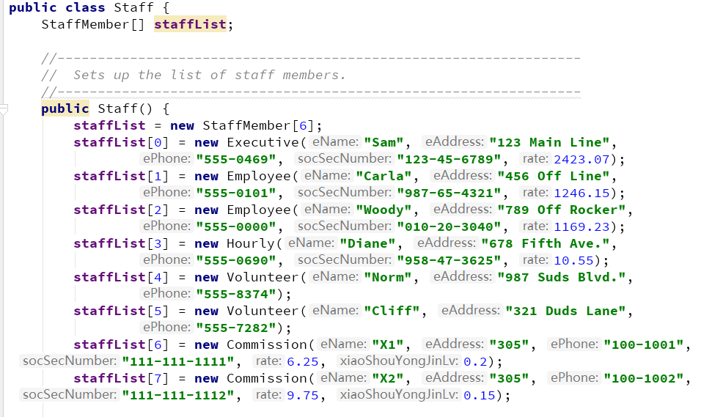

package chapter09.p1;
/**
* @Description:
* @Author: QiuGuanLin
* @Date: 2018/5/25 10:29
*/
public class Commission extends Hourly {
private double totalSales;
private double xiaoShouYongJinLv;
public Commission(String eName, String eAddress, String ePhone, String socSecNumber, double rate, double xiaoShouYongJinLv) {
super(eName, eAddress, ePhone, socSecNumber, rate);
this.xiaoShouYongJinLv = xiaoShouYongJinLv;
}
public void addSales(double totalSales) {
this.totalSales += totalSales;
}
@Override
public double pay() {
return super.pay() + totalSales * xiaoShouYongJinLv;
}
@Override
public String toString() {
return super.toString() + "\nTotalSales: " + totalSales;
}
public double getTotalSales() {
return totalSales;
}
public void setTotalSales(double totalSales) {
this.totalSales = totalSales;
}
public double getXiaoShouYongJinLv() {
return xiaoShouYongJinLv;
}
public void setXiaoShouYongJinLv(double xiaoShouYongJinLv) {
this.xiaoShouYongJinLv = xiaoShouYongJinLv;
}
}

2) Results data processing
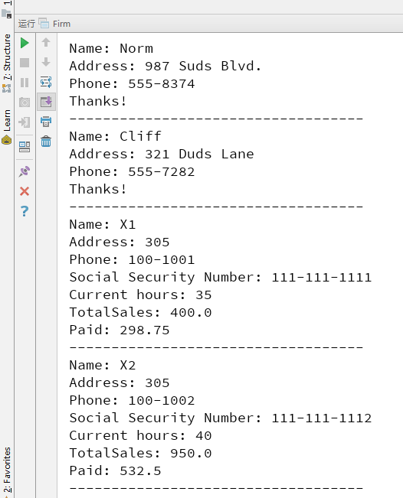

3) Answer questions

4)Error Analysis and Discussion

2 Speed Control
1) Source code list
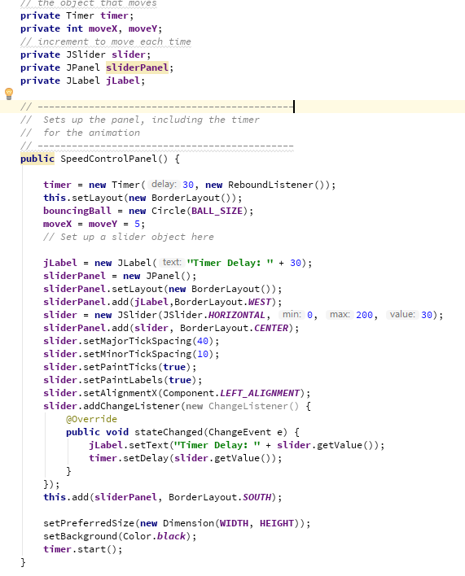

2) Results data processing
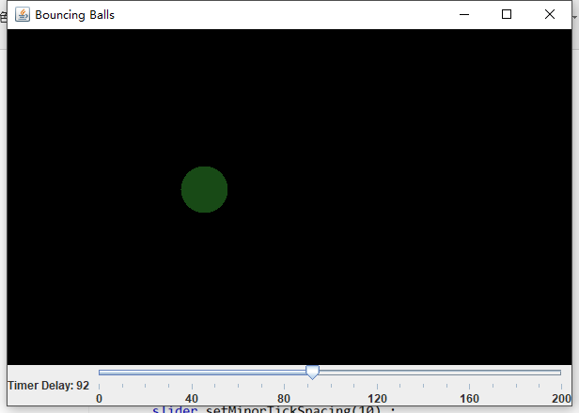

3) Answer questions

4)Error Analysis and Discussion

1 Another Type of Employee
1) Source code list

2) Results data processing

3) Answer questions

4)Error Analysis and Discussion

